Help for Save My Health Information to My Computer
The Save My Family History button on the My Family page will allow you to save the family history you have created to the hard drive of your computer or to a portable device. We recommend saving your own health information to your computer. The process for saving your health information to My Computer may vary depending on your Web browser and operating system. Please look below to see which set of instructions is applicable to your browser and operating system.
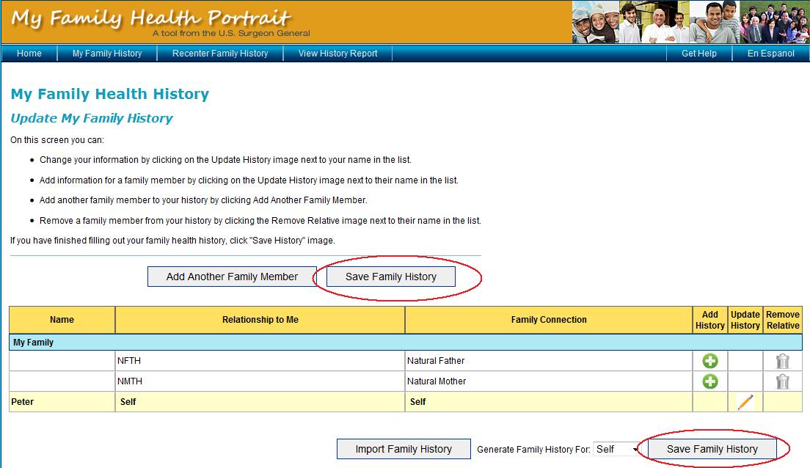
Additional Instructions for Firefox users on Windows
1. After clicking the Save button, a new pop-up window will appear. In this window (as shown in the sample picture below), only select the Save to Disk radio button and click the OK button.
2. Please remember to make note of where you saved your file!

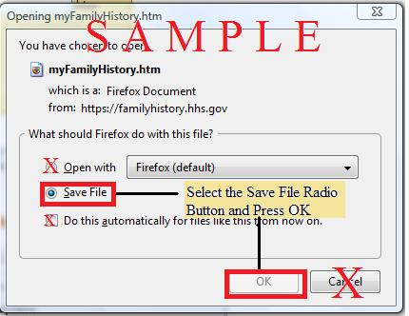

Additional Instructions for Internet Explorer users on Windows
1. After clicking the Save button, a new pop-up window will appear. In this window (as shown in the sample picture below), only click the Save button.
2. Please remember to make note of where you saved your file!

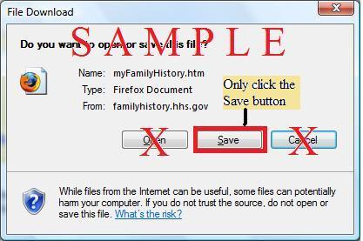

Additional Instructions for Safari users on Windows
1. After clicking the Save button, a new pop-up window will appear. In this window (as shown in the sample picture below), only click the Save button.
2. Please remember to make note of where you saved your file!

